SWE-503
SOFTWARE CONFIGURATION MANAGEMENT
PROJECT
ON
“online QUIZ”

By
13mse0172(Saranya P)
13mse0121(Priyadharshini J)

INTRODUCTION:
The ONLINE QUIZ is a web application for to take online test in an efficient manner and no time wasting for checking the paper. The main objective of ONLINE QUIZ is to efficiently evaluate the candidate thoroughly through a fully automated system that not only saves lot of time but also gives fast results. For students they give papers according to their convenience and time and there is no need of using extra thing like paper, pen etc.
TRADITONAL METHOD:
- The lecturer used to conduct the manual quiz for student as a assessment.
- Paper quizzes
Disadvantage:
- Time consuming.
- Lots of paper records.
- Difficulty in managing records.
- Evaluation will be difficult.
- Quiz schedule will be a problem.
PURPOSE AND SCOPE:
This Web Application provides facility to conduct online examination worldwide.
It saves time as it allows number of students to give the exam at a time and displays the results as the test gets over, so no need to wait for the result. It is automatically generated by the server.
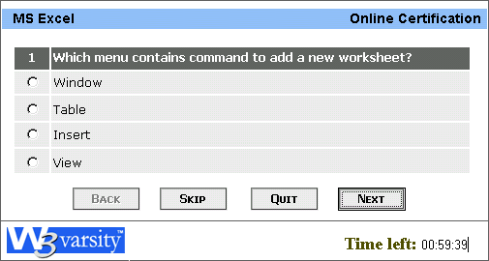
Scope of this project is very broad in terms of other manually checking yourself.
- This can be used in educational institutions as well as in corporate world.
- Can be used anywhere any time as it is a web based application.
- User can able to view their results at once.
FEATURES OF PROPOSED SYSTEM:
- FUNCTIONAL CAPABILITIES: The ultimate aim of this project is to help the quiz analysis and facilitate the faculties for easy evaluation of the students and generation of the automatic score cards.
- PERFORMANCE LEVEL: The scope of this project gives immense opportunity for the students to know their levels in quiz. It provides effective software so as to help the students as well as the evaluators who are involved in evaluating the student’s performance.
- SAFETY: No data loss occurs in the quiz system.
It is very much protected in such a way that it gives permission to the students to access only when the username and password is correct.
- DATA STRUCTURES: The data in this project are maintained in the tabular form using MYSQL in the form of database. It provides easy access to the user. Easy category questions are maintained in the database which provides easy for the user to access and choose the category.
- RELIABILITY: We assure that the project is completely authenticated in order to enhance security and corruptions of database as well as the software.
- QUALITY: The project is developed with the help of visual basic 6.0 software which meets the requirement of the user, the project is checked whether the phases individually have a served its purpose.
INTERFACE REQUIREMENTS:
- WAMP SERVER
Any updated version of wamp server with the adaptability of PHP and SQL server.
- A BACK END DATABASE-SQL
- FRONT END- BROWSER

USE-CASE
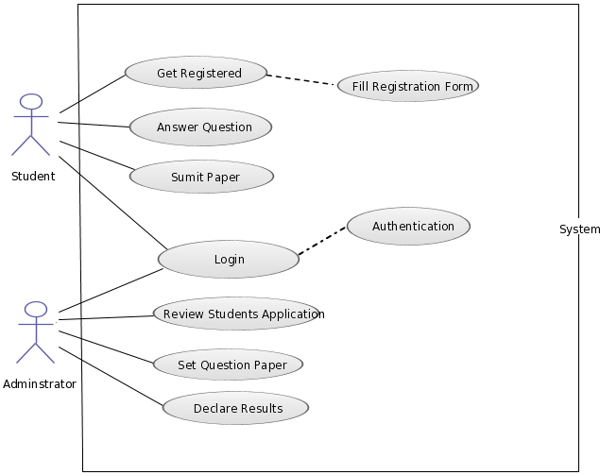
SCM plan:
The purpose of Software Configuration Management (SCM), in general, is to establish and maintain the integrity of work products using:
- Configuration Identification
- Configuration Control
- Configuration Status Accounting
- Configuration Audit
CI
A Configuration Item (CI) is an entity designated for configuration management, which may consist of multiple related work products that form a baseline.

ADMINISTRATOR
1. Authentication phase
2. Question generation phase
3. Report generation phase
PARTICIPANT- STUDENT/USER
1. Authentication phase
2. Registration phase
3. Rules and category selection phase
4. Question bank phase
5. Result generation phase

SCM Activities:
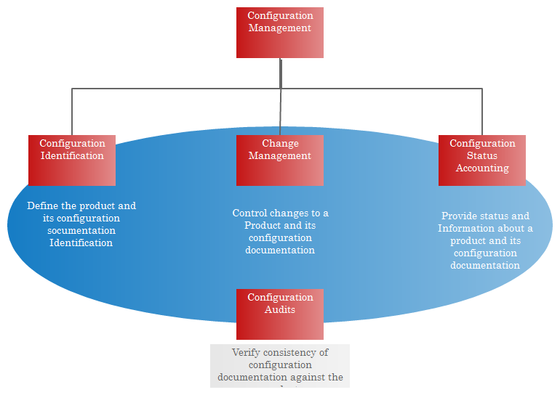
- Identification:
The way software configuration items will be identified for the software configuration management plan.
Identify change.
During the software development phase a team member suggests a change in the adding more complex question then we need to have the team work on the suggestion and to figure out if the change is necessary and is justified.
Approve change
Support to change management team by approving requested question changes and assisting in the assessment and prioritization of changes.
Ensure that change is being properly implemented:
The team members looking over the change .We want to set up times when team members will look over the change that other members have implemented and to finalize the change .
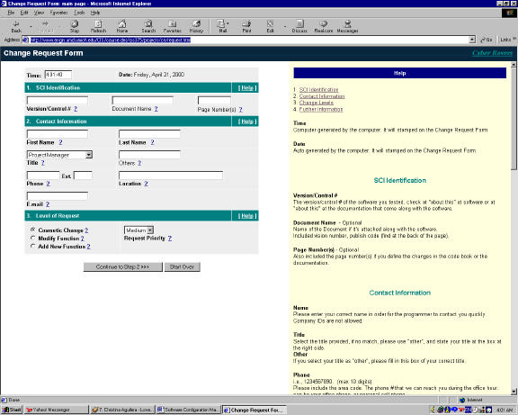
2.Configuration Control :

Its purpose is to ensure that all changes to a complex system are performed with the knowledge and consent of management.
Steps, which will be taken in order to control change:
- Request the change
- Software developer will evaluate the change request
- The result of the evaluation will be presented as change report
- Final decision on change will be made
5) If change is approved
1. Define constraint
2. “Check out” items for changes
3. Make necessary change
4. Apply SQA activities
5. “Check in” items
6. Apply testing activities
7. Rebuilt the software
8. Distribute the software
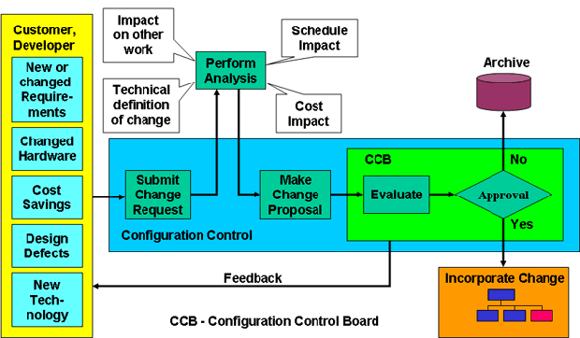
3.Version Control:
Version control is a system that records changes to a file or set of files over time so that you can recall specific versions later.
If major functionality has been added to the quiz that greatly increase the user’s experience or greatly improves the program performance, a minor version update will be issued immediately.
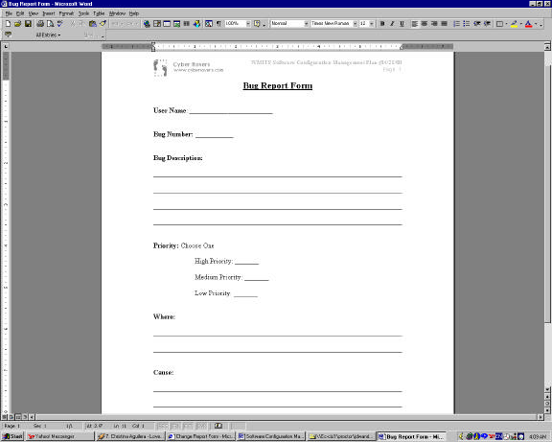
4.Configuration Status Accounting (CSA) :
Three different ways to communicate with the team members and to inform others that changes may concern
Online help desk:
A help desk is usually operated by individuals that have an extensive background of the appropriate system, so that they can walk users through step-by-step solutions for their problems.
Change request report:
A change request is a document containing a call for an adjustment of a system; it is of great importance in the change management process
Verbal communication:
Messages or information is exchanged or communicated through words .
Screenshots:

